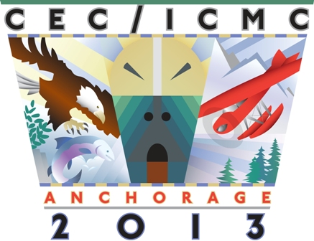
CEC/ICMC 2013

Cryogenic Engineering Conference & International Cryogenic Materials Conference
June 17 - 21, 2013  Anchorage, Alaska, USA

ON-SITE REGISTRATION FORM

First Name: |  | Middle Initial: |  |  |  | Last Name (Surname):
Title: |  |  |  | Affiliation:
Mailing Address:

City: | State/Province: |  | Zip/Postal Code: |  |  |  | Country:
Phone:  (If outside the US or Canada, please include country and city code as applies.) |  |  |  |  | Fax:
Email: |  |  |  |  | Alternative Email:

➢ Do not include my contact information in the CEC/ICMC 2013 email distribution list.
➢ Do not include my address, phone/fax numbers and email address in the attendees list.

I am attending as: a CEC Participant an ICMC Participant Both

For future conferences, would you be interested in transactions being produced in CD format only? Yes No

Is this your first CEC/ICMC? Yes No

Gender: Male Female

If you have any dietary needs, please provide here:

REGISTRATION FEES | ON-SITE FEES
Full Conference Registration  (Includes admission to all Technical sessions, Exhibits, Social Events, and  EITHER CEC or ICMC transactions. PLEASE CHOOSE ONE.) | US $900
Student Registration – Not available to post-doctoral fellows. Student ID required at on-site check in. (Includes admission to all Technical session, Exhibits, Social Events, and EITHER CEC or ICMC transactions. PLEASE CHOOSE ONE.)  Enter Student ID number here: | US $450
RETIREE REGISTRATION  (Includes admission to all Technical session, Exhibits, Social Events and  EITHER CEC or ICMC transactions. PLEASE CHOOSE ONE.) | US $450
TOTAL:

OTHER OPTIONAL FEES | # of tickets | Fee | Total
Welcome Reception (One Days/Companions/Guests) – Mon., June 16, 2013 |  | US $40 | $
Exhibitor Reception (One Days/Companions/Guests) – Tues., June 17, 2013 |  | US $55 | $
Fun Run (Registrants/One Days/Companions/Guests) – Wed., June 19, 2013  Please select: Small Medium Large X-Large XX-Large  (T-shirts and sizes are NOT guaranteed for onsite registrations) |  | US $25 | $
Farewell Event (One Days/Companions/Guests) – Thurs., June 20, 2013 |  | US $75 | $
Additional Set of Transactions (select CEC or ICMC) |  | US $100 | $
 |  | TOTAL: | $

PAYMENT INFORMATION

Total PAYMENT Amount: US $

Check Number: Traveler’s Checks

Checks or Traveler’s Checks must be in U.S. dollars, drawn on a U.S. bank, payable to “Cryogenic Engineering Conference, Inc.”. A $20 administrative fee will be applied for all returned checks.

Cash

Credit Card VISA MasterCard Discover
Note: CEC/ICMC 2013 does not accept American Express cards. We apologize for the inconvenience.

Please complete the information below:
Card Number: | Expiration Date:
Security Code: | Billing Zip/Postal Code:
Cardholder Name: | Today’s Date:
Cardholder Signature:

Important Credit Card Information
Credit card information will only be kept on file until 90 days following the Conference and is stored securely. Credit card information will not be saved electronically and will be shredded after the conference. Credit card information will not be shared and is only available to Centennial Conferences’ employees authorized to accept and process credit cards.

