CEC/ICMC 2013
Anchorage, Alaska, USA  June 17 - 21, 2013
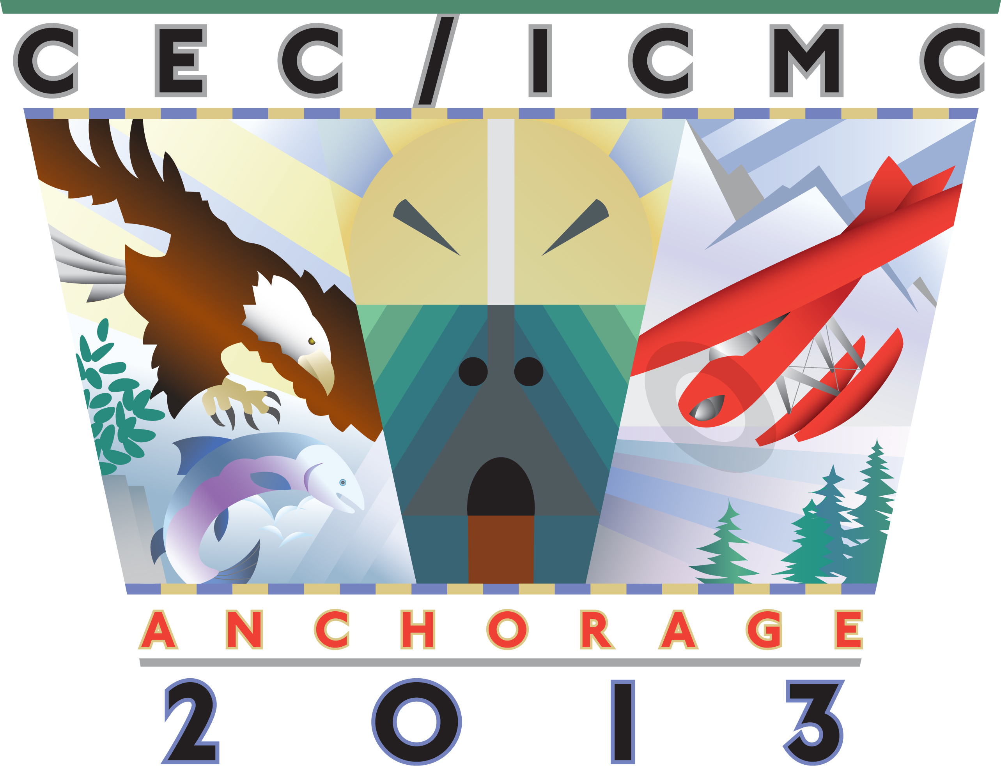

Sponsorship and Advertisement Order Form

Deadline: May 1, 2013

Contact Information
Contact Name:
Company:
City/State/Country:
Phone: | Email:
Website:

Sponsorship Opportunities
Conference Bag (limited to 1 sponsors) – SOLD |  | $5,000
Student Grants (unlimited sponsors) |  | $2,500
Coffee Breaks (limited to 7 sponsors) |  | $2,000 |  | # of breaks:
Farewell Reception Entertainment (limited to 1 sponsor) |  | $5,000
Friday Special Speaker (limited to 1 sponsor) |  | $5,000
Program Book Sponsor (limited to 4 sponsors) |  | $900
Promotional Materials & Inserts for Conference Bags
 | Conference Badge Lanyard – SOLD | $2,000
 | Promo Pen | $1,000
 | Promo Highlighter | $1,000
 | Promo Notepad | $1,000
 | Promo Flash Drive | $1,000
 | Single Printed Sheet | $1,000

Advertisement Opportunities
Inside Front Cover (color) | $1,500
Inside Back Cover (color) | $1,500
Full-page Internal (black & white) | $1,000
Literature Table | $300

Select your preferred form of payment: Check Bank Wire Credit Card (Visa/MC/Discover only)

Please send form to:
Centennial Conferences
Email: cecicmc@centennialconferences.com; Fax: 1-303-499-2599; Phone: 1-303-499-2299

SPONSORS: Please send logos electronically in JPG, GIF or TIFF format to cecicmc@centennialconferences.com.

