CEC/ICMC 2021
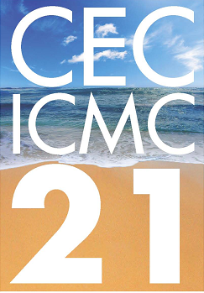

Cryogenic Engineering Conference & International Cryogenic Materials Conference
May 16 – 20, 2021 Honolulu, Hawaii, USA

APPLICATION FORM

Klaus and Jean Timmerhaus Scholarship Award

Full Legal Name:
Date of Birth:
Reply Address:
Address:
Suite/Apt.(optional):
City:
State/Province:
Country:
Postal Code:
Permanent Address (only complete if different from Reply Address):
Address(optional):
Suite/Apt.(optional):
City(optional):
State/Province(optional):
Country(optional):
Postal Code(optional):

Contact Information:
Daytime Phone:
Evening Phone:
Fax(optional):
Email:
City of Birth:
State of Birth:
Country of Birth:
I am a Citizen of:
List of all colleges and universities attended, major field, dates of attendance, and actual name of the degrees received or expected. List most recent first. Please add additional one at the end of the page.
College/University 1:
College/University Name:
Location:
Major Field:
Dates Attended:
Name of Degree/Diploma:
Date Degree Awarded/Expected:
Names of persons who you are listing as your references (minimum 2)
Reference 1:
Name:
Title:
Institution/Company:
Email:

Reference 2:
Name:
Title:
Institution/Company:
Email:
Name and contact information of potential/current advisor under which the scholarship is expected to be executed:
Name:
Title:
Address:
Suite/Apt.(optional):
City:
State/Province:
Country:
Postal Code:
Daytime Phone:
Email:
Proposed Research
Please provide a description of the type of research that you intend to do while supported by this scholarship:

Professional Experience (including summer and term time work)
Employer 1:
Employer(optional):
Title(optional):
Nature of work(optional):
Responsibilities and Accomplishments(optional):
Other Experience (including military and voluntary work)
Give names of employers, dates, and nature of work:
Other Relevant Information
Your Honors, Prizes, and Major Publications:

Extracurricular Activities and Accomplishments:
Additional Universities / College information and References

Additional Colleges / Universities / References

Please submit application form to Al Zeller via email at zellera@msu.edu by March 1, 2021.

